Sample Protocol for Conducting a Community Survey
Contents
Introduction 1
Assessment Area 1
Procedures 2
Household visits (See Algorithm for Household Visit Procedures) 2
Participating households 2
Collection of diagnostic specimens and laboratory testing 3
Following up with household members 3
Ethical issues 4
Appendix A. Sample Introduction Script for Community Survey 4
Appendix B. Sample Consent Document for Household Community Survey 6
Appendix C. Sample “Sorry we missed you” Note with Information on Evaluation 8
Appendix D. Sample “Thank you for participating” Note 9
Appendix E. Sample Results Letter 10
Algorithm for Household Visit Procedures* 11

Introduction
Local mosquito-borne transmission of Zika virus should be assumed when a case is confirmed and other routes of exposure, such as travel, sexual contact, and blood/body fluid exposure have been evaluated and ruled out. Under these circumstances, states and local jurisdictions should implement targeted surveillance for Zika virus infection among household members of the confirmed, locally acquired case and among neighboring households and any other likely sites of transmission identified through the case investigation.

Assessment Area
Evaluate household members of the index case and residents of households within at least a 150-meter radius of the index case’s residence for local transmission given the flight distance of Aedes aegypti and Ae. albopictus mosquitoes. Assess households where at least one resident of the house has lived in the household for the last month. Establish criteria for defining a household member – e.g., a person needs to have slept in the house at least 2 days per week during the month before onset of the index case’s symptoms. Exclude from the assessment young children (aged <5 years) and others with certain conditions making them ineligible for an interview and/or specimen collection (e.g., nonverbal, bedbound).

Consider other locations of potential mosquito exposure, such as workplaces with significant outdoor exposure, to investigate for possible local transmission.

Procedures

Household visits (See Algorithm for Household Visit Procedures)

Households within at least a 150-meter radius should be visited by investigation teams consisting of an interviewer and a person familiar with the local area. To ensure the safety of field teams, all investigation teams should have at least two people. Provide information in the language appropriate for the household; if the household members do not speak English, attempt to identify someone who is able to speak the household’s primary language. The Household Visit Log (https://www.cdc.gov/zika/public-health-partners/visit-log.xlsx) can be used to track the visit dates/times and participant status.

- Knock on the door, introduce yourself, and ask to speak to the head of the household. If the head of the household is available, ask if he/she is willing to hear about the evaluation (Appendix A, Step 1). If he/she is willing, provide a brief description of the evaluation and ask if he/she is willing to hear more details (Appendix A, Step 2).
- If the head of household or other adult elects not to talk to the investigation team, mark the household as having “Declined” participation on the Household Visit Log (https://www.cdc.gov/zika/public-health-partners/visit-log.xlsx). Thank him/her for their time, offer insect repellent and provide information about Zika virus disease symptoms and preventing mosquito-borne diseases (use available resources from CDC or Department of Health [see http://www.cdc.gov/zika/comm-resources/index.html]).
- If the head of household or other adult agrees to hear more about the evaluation, describe it in more detail according to the consent document (Appendix B). If possible, ask all household members to listen to the information and ask if they have any questions. Provide a copy of the consent document to the household members for their reference. If after reading (or being read) the consent document, the household member(s) do not want to participate, mark the household as having “Declined” participation on the Household Visit Log (https://www.cdc.gov/zika/public-health-partners/visit-log.xlsx). Thank him/her for their time, offer insect repellent and provide information about Zika virus disease symptoms and preventing mosquito-borne diseases. Proceed to the next household.
- For households where no residents, heads of household, or other adults are available on the initial visit, place a note on the door or provide the note to people who are home notifying them that the team will visit them again and providing a number at the health department if they want more details about the assessment or would like to schedule an appointment (Appendix C). Proceed to the next household. Revisit households that do not answer at the first visit two more times at a different time and/or day of the week. If after three visits, no one answers or no head of household or other adult is available, exclude the household and mark the household as “Unavailable” on the Household Visit Log (https://www.cdc.gov/zika/public-health-partners/visit-log.xlsx).
- If any members of a household are not present at the time of the visit, revisit the household at least twice to enroll additional household members. If additional household members are identified when revisiting the household, provide them with information about the evaluation (Appendix B) and ask them if they have any questions.

Participating households

- After the household members are provided with information about the evaluation and their questions have been answered, obtain verbal consent to participate (Appendix B) from all household members aged ≥ 18 years. In addition, obtain verbal consent from the parent or legal guardian of any minors (children aged 5–17 years). The age at which assent is sought for children will be determined by local/state health authorities. In determining whether children are capable of assenting, consider the ages, maturity, and psychological state of the children involved. Verbal consent will be sought as the investigation presents no more than minimal risk of harm and involves no procedures for which written consent is normally required. Once verbal consent is obtained, collect the names, ages, and sex of all household members and verify that each person is considered to be a household member. Assign each household member a unique identification (ID) number. Household and household member information can be recorded on the Household Member Survey Form (https://www.cdc.gov/zika/public-health-partners/household-survey-form.docx).
- The Household Member Survey Form (https://www.cdc.gov/zika/public-health-partners/household-survey-form.docx) can be used to capture information on household demographics (name, relationship to index case, sex, date of birth, pregnancy status [if applicable]); interview consent status; presence and onset dates of Zika virus disease-like symptoms within the 2 months before the index patient’s symptom onset; and recent travel history.
- If a household member reports recent symptoms consistent with Zika virus disease, use the Zika Virus Infection Case Investigation Form (https://www.cdc.gov/zika/public-health-partners/infection-case-investigation-form.docx) to collect full information on possible risk factors for Zika virus infection, including potential sexual or blood-borne exposure. The health department should determine the appropriateness of questions to ask depending on the age of the household member and individual circumstances.

Collection of diagnostic specimens and laboratory testing

When possible, collect urine and serum specimens from household members (aged ≥ 5 years) of the index case for rRT-PCR and Zika virus IgM testing. Household members who report recent symptoms of Zika virus disease (i.e., fever, rash, arthralgia, conjunctivitis) should be tested for Zika virus infection according to CDC recommended testing algorithms (https://www.cdc.gov/zika/laboratories/lab-guidance.html).

The same guidance for consent and assent as described above for the interview applies to requests for specimens from household members. See https://www.cdc.gov/zika/laboratories/test-specimens-bodyfluids.html for more information on collecting body fluid specimens for Zika virus testing.

Following up with household members
Upon completion of the survey and specimen collection, thank the household members for their time, offer insect repellent, and provide information on preventing mosquito-borne diseases. Leave a “Thank you for participating” note (Appendix D) with the household along with the information on preventing mosquito-borne diseases. Ask participating household members to notify the health department if symptoms of Zika virus disease develop. Consider following up with households 14 ̶ 21 days after initial contact to determine if any additional household members have symptoms.

Results of testing
Send a letter to all participating households with the test results of all household members upon completion of testing (Appendix E). For people who test positive for evidence of a recent Zika virus infection, perform additional case investigation per state guidelines for the investigation of nationally notifiable diseases. The Zika Virus Infection Case Investigation Form (https://www.cdc.gov/zika/public-health-partners/infection-case-investigation-form.docx) may be used to identify possible risk factors for Zika virus infection, with subsequent follow-up investigation as needed.

Ethical issues

For those agreeing to participate in the public health investigation, there is a risk of personal health information unintentionally being revealed to those outside the investigation team. However, the investigation team should seek to mitigate this risk by keeping any personally identifiable information locked and/or password-protected. In addition, all participant data should be entered by coded ID number into an electronic database and stored in a locked computer.

Specimen collection and Zika virus testing for the purposes of the public health investigation should be free of charge. People who are approached by the survey team should be given information about preventing mosquito-borne diseases. Participants will potentially benefit by knowing if they were infected with Zika virus and take appropriate precautions to limit further transmission.

Appendix A. Sample Introduction Script for Community Survey

Step One: Introduction

Hello, my name is (insert name). We are with the [name] County (or State) Department of Health.

May we speak to the head of the house, please?
- If unavailable: Is there another adult in the house?
- If unavailable: Here is some information about how to prevent mosquito bites. We also would like to give you this insect repellent.
- If yes: Continue to next question.

To head of household or other adult: We are working to learn if people in this area may have recently become infected with Zika virus from mosquito bites. May we talk to you about what we are doing?
- If no: Thank you for your time. Here is some information about Zika symptoms and how to prevent mosquito bites. We also would like to give you this insect repellent.
- If yes: Continue with the remaining script.

Step Two: Description of Evaluation

Thank you. You may have heard about Zika, which is a virus spread to people by some types of mosquitoes when they bite you. Some people may get a fever, rash, red eyes, joint pain, muscle pain, or headache from the virus. This virus can be serious for pregnant women because it can cause serious birth defects.

Right now, we don’t have proof that mosquitoes in this neighborhood have Zika virus or are spreading Zika virus, but we would like to talk briefly with each person who usually lives in this house to ask if they have been sick recently and if they are willing to provide a blood and urine sample.

Your participation is voluntary. It will help us at the health department find out if people in this area may have become infected with Zika virus from mosquitoes. If we find out that this has happened, we will take further action to prevent mosquitoes from spreading this virus.

May I read you information on the evaluation or, would you like to read it, and then you can decide if you are willing to participate?

- If no: Thank you for your time. Here is some information about Zika symptoms and how to prevent mosquito bites. We also would like to give you this insect repellent.
- If yes: Continue to consent form.

Appendix B. Sample Consent Document for Household Community Survey
(Flesch-Kincaid Reading Level 7.2)

What is this survey?

The [name] county (or state) health department is trying to determine if mosquitoes in the area may be causing some people to get Zika virus infection. Zika virus is spread to people by some types of mosquitoes through bites. Some people may get a fever, rash, red eyes, joint pain, muscle pain, or headache from this virus. Many people infected with Zika virus won’t have symptoms or will only have mild symptoms that they may not remember.

What is the purpose of this survey?
The purpose of this evaluation is to find out if people in this area may have become infected with Zika virus from mosquitoes. If we find out that this has happened, local health departments and mosquito control districts will take further action to prevent mosquitoes from spreading this virus. This is important, because if a pregnant woman gets infected with Zika, the virus can cause birth defects.

What do I need to do for this survey?
If you agree, we will ask you questions about your exposures to mosquitoes and your health. [We would also like to collect a blood and urine sample]. It should take about 10 minutes to answer the questions [and have you provide a blood and urine sample].

What will happen to my blood and urine samples?
Your blood and urine samples will be tested to see if you have likely been infected by Zika virus. At the end of the evaluation, your samples will be destroyed.

What if I do not want to take part in this survey?
Taking part in this evaluation is voluntary. You do not have to answer any question that you do not want to.

What are the benefits for being part of this survey?
[By testing your blood and urine, we will be able to tell you if you were likely infected with Zika virus.] The information you provide will help us learn whether mosquitoes in the area may be spreading Zika virus. If we find out that this has happened, local health departments and mosquito control districts will take further action to prevent mosquitoes from spreading this virus.

What are the risks for being part of this survey?
There is a small risk of your personal health information unintentionally being revealed to those outside the investigation team. We will keep the information you provide private to the extent allowed by law. We will not share your information with anyone who is not part of this evaluation team. When we talk or write about the findings of this evaluation, we will not include any details about you that might identify you.

Are there any costs or payments for participating?
There is no cost for you to be in this evaluation. The testing we will do to know if you had Zika virus infection is free.

How do I learn more about this evaluation?
We would be happy to answer any questions you might have about this evaluation. If at any time you have questions or would like to stop participating, please contact [Name] at the health department at ___-___-____. Someone will call you back as soon as possible.

Do you have any questions?

For people aged ≥18 years (consent)
Do you agree to take part in this evaluation?

For parents or guardians of children aged 5–17 years old (consent)
Are you willing to allow your child to take part in this evaluation?

For children aged < 17 years (assent; age range to be determined by local/state health authorities based on the ages, maturity, and psychological state of the children involved)
Are you willing to answer some questions and give us a blood and urine sample?

Appendix C. Sample “Sorry we missed you” Note with Information on Evaluation
(Flesch-Kincaid Reading Level 7.3)

Sorry We Missed You!

Hello. The [name] county (or state) Health Department is hoping to talk with people who live in your house. We want to share information with you about an evaluation on mosquitoes and the viruses they spread.

We are working to find out if people in this area may have become infected with Zika virus from mosquitoes. If we find out that this has happened, local health departments and mosquito control districts will take further action to prevent mosquitoes from spreading this virus. This is important, because if a pregnant woman gets infected with Zika, the virus can cause birth defects.

We are hoping to talk to people in about (no.) of houses in this area. We are going house-to-house to talk to everyone who is willing to participate.

The information you provide will help us learn about whether mosquitoes in the area may be spreading viruses that make people sick. Taking part in this evaluation is voluntary.

We would like to talk to you in person about this evaluation so you can decide if you want to participate. We will stop by again later today or tomorrow.

If you prefer to schedule a time for us to stop by, please call the [name] county (or state) Health Department. If you do not want us to visit your household again, you can also call the health department and let them know.

The phone number for the Health Department is ___-___-____. Please tell them your address when you talk to them.

Appendix D. Sample “Thank you for participating” Note
(to be left along with mosquito bite prevention information)

Thank you for talking with us today!

The information you provided today will help the [name] county (or state) Health Department learn more about mosquitoes in the area and whether people may have recently been sick from mosquito bites.

If you have any questions, the phone number for the health department is ___-___-____. Please tell them your name and address when you talk to them.

Thank you for helping to protect the health of your family and community members.

Appendix E. Sample Results Letter

Dear Sir/Madam,

Thank you for taking part in our evaluation of possible local mosquito-borne transmission of Zika virus in [name of area]. The information you provided was critical to our understanding whether Zika virus was spread by mosquitoes in your area. It also helped us understand more about this new virus.

We have finished testing the blood and urine samples you provided for Zika. Please see your test results below.

Name | Results
[Name] | Your test results show you [may] have been recently infected with Zika virus.
[Name] | Your test results show you have not been recently infected with Zika virus.

If your test results showed that you have been infected with Zika virus, you should be protected from getting infected with Zika virus again in the future. If your test results indicated that you have not been infected with Zika virus, we encourage you to take actions to prevent yourself from becoming infected with Zika virus or other mosquito-borne viruses. A few simple ways to prevent diseases spread by mosquitoes include:

Cover bare skin and avoid mosquito bites:
- Use EPA-registered insect repellents on exposed skin when outdoors. Look for these active ingredients: DEET, picaridin, IR3535, oil of lemon eucalyptus, para-menthane-diol, or 2-undecanone.
- Wear long sleeves and long pants.
- Treat your clothing and gear with permethrin or buy pre-treated items (except in Puerto Rico, where permethrin is not effective).

Mosquito-proof your home:
- Reduce the number of mosquitoes in and around your home by limiting the places they can lay eggs.
- Use screens on windows and doors, and use air conditioning when possible.
- Once a week, empty and scrub, turn over, cover, or throw out any items that hold water like tires, buckets, planters, toys, pools, birdbaths, flowerpot saucers, or trash containers. Mosquitoes lay eggs near water.

More information about Zika and prevention of mosquito bites can be found at: http://www.cdc.gov/zika/about/index.html (or Health Department website).

If you have questions or concerns about your results, please contact the [name] county (or state) Department of Health at ___-___-____.

Algorithm for Household Visit Procedures*

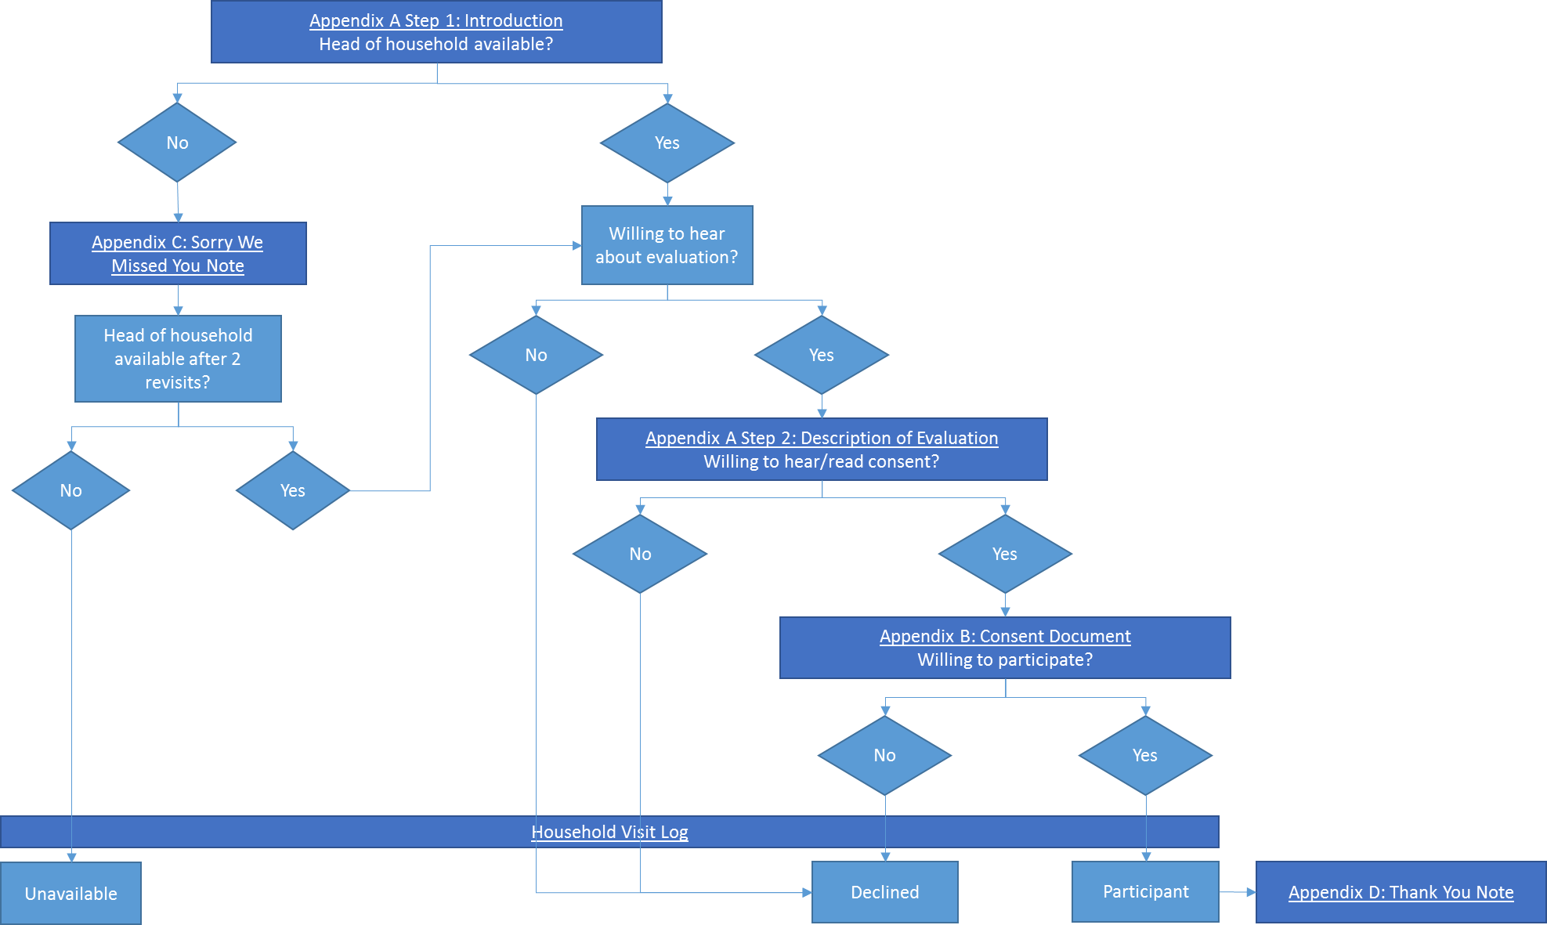
* Regardless of participation, thank household members for their time, offer insect repellent, and provide information about Zika virus disease symptoms and preventing mosquito–borne diseases (http://www.cdc.gov/zika/comm-resources/index.html).

If index case was asymptomatic, use specimen collection date in place of onset date.
If index case was asymptomatic, use specimen collection date in place of onset date.
Blood and urine specimens should be collected for Zika virus testing from household members of the index case and people reporting signs or symptoms consistent with Zika virus disease within 2 months before onset of symptoms of the index case (if index case was asymptomatic, use specimen collection date in place of onset date).
Question pertains to household members of the index case and people reporting signs or symptoms consistent with Zika virus disease within 2 months before onset of symptoms of the index case (if index case was asymptomatic, use specimen collection date in place of onset date).
Blood and urine specimens should be collected for Zika virus testing from household members of the index case and people reporting signs or symptoms consistent with Zika virus disease within 2 months before onset of symptoms of the index case (if index case was asymptomatic, use specimen collection date in place of onset date).

