Chapter 3

Documenting Day-to-Day Healthcare Delivery
Working Premise
You cannot plan for medical surge management if you don't understand how your community's healthcare system delivers care on a day-to-day basis.

Overview

Introduction
Each chapter in the Framework that follows this chapter focuses on increasing levels of medical surge. Before you and your planning team can work through those chapters, however, you need to first understand how your community's healthcare system delivers care on a day-to-day basis.

A term used in the Framework to describe your community's delivery of healthcare is "model of care" or MOC (pronounced MOCK), which is a shortened version of "model of healthcare delivery." Although the term uses the singular form of model, you should not assume that one model can represent how your community's healthcare providers deliver care. Certain situations call for the model to be adjusted to meet the demands of that situation. For example, as you will see in the ensuing chapters in the Framework, increasing levels of medical surge will require your community's healthcare providers to incorporate an alternate care system or to provide only essential healthcare services or to define crisis standards of care.

In this chapter, however, the focus is not on medical surge, but rather on the day-to-day delivery of healthcare. More likely than not, this day-to-day activity will include some form of medical surge because hospitals and other healthcare providers normally experience "spikes" in the demand for their services on a day-to-day basis. The reason this chapter focuses on this day-to-day delivery of healthcare is that you and your planning team must first understand your community's "baseline" of healthcare delivery before you can determine how to best adjust it to meet the needs of increasing medical surge as described later in the Framework.
The MOC that you develop in this chapter will provide your coalition, and even the public, with a greater understanding of your community's healthcare delivery system. Seldom identified on a day-to-day basis, this MOC also can help to identify potential areas for improvement to meet your community's needs.

Definition
Model of Care A concept used to describe how community healthcare providers deliver care during specific situations to meet the needs of their patients. This model can represent day-to-day patient care or the provision of care during moderate or heavy surge situations. A MOC includes (1) a diagram of patient flow through various community healthcare providers and their supporting partners and (2) a narrative description of this patient flow.

HPP/PHEP Capabilities Addressed by This Chapter
The HPP and PHEP capabilities listed below are addressed by this chapter.

HPP
Capability 1: Healthcare System Preparedness
Capability 3: Emergency Operations Coordination
Capability 5: Fatality Management
Capability 6: Information Sharing
Capability 10: Medical Surge

PHEP
Capability 1: Community Preparedness
Capability 3: Emergency Operations Coordination
Capability 5: Fatality Management
Capability 6: Information Sharing
Capability 10: Medical Surge

What to Expect After Completing This Chapter
- You will have an understanding of the day-to-day system of healthcare delivery in the community, which will help to enhance your community's medical surge planning efforts.
- You will have a diagram to make it easier for your planning team and coalition to "visualize" how patients move through your healthcare system on a day-to-day basis.
- You will have a narrative to enable you to exercise and validate your MOC

Applicability and Scope
Documenting day-to-day healthcare delivery is applicable to all communities regardless of size. Documentation (i.e., the MOC diagram and narrative) should cover all sectors represented within the community's healthcare delivery system.

Assumptions
- The planning team and key partners will play an active role in each phase of documenting your community's day-to-day MOC.
- A community-wide MOC has not been documented.

Issues and Barriers to Consider
- Participation of community partners may vary over time as the focus of the planning team and their projects change.
- The engagement of some partners may require approval of leadership at a national level or higher organization level (e.g., national chain pharmacies).

Documenting Your Model of Day-to-Day HealthCare Delivery

Overview
Identifying your community's day-to-day MOC is a four-step process:
- Conduct a community demographics and partner assessment.
- Develop a MOC diagram and a MOC narrative.
- Evaluate your MOC diagram and narrative with your partners.
- Validate your MOC diagram and narrative with your coalition.

Conduct a Community Demographics and Partner Assessment
The goal of this step is to provide community planners with a clear understanding of the community's demographics, available partners, and the services available at each location. Information gathered in this phase will be used to develop your community's MOC diagram and MOC narrative.

Community Demographics Assessment
Conducting a community demographics analysis is a prerequisite to all parts of the planning process. Information concerning the structure and dynamics of local populations is essential to
- Identifying and anticipating problems and community needs
- Establishing short- and long-range program goals
- Developing action plans
- Identifying fiscal and human resources
- Evaluating the impact of any given event

A community's demographics may include the following components:
- Geographic Makeup
The geographic location, including square miles, relationship to neighboring communities/counties, topography, and information on climatic and geologic conditions (e.g., floodplains, locations of major surface water bodies)
- Community Description
  - The type of community, such as large, small, or midsized city
  - The name of the county in which the community resides
  - The names of cities, boroughs, townships, and villages that are located in the county
- Population Size
The approximate population of the county, cities, and boroughs, townships and villages
- Composition
  - The age distribution of the population
  - The types of households (e.g., family and nonfamily)
  - Cultural distribution
  - Economic makeup

Please use Worksheet 3.1 – Community Demographic Assessment on the next page to identify your community's demographics. You will incorporate the information you collect into your MOC narrative. (An example of how this information is included in a MOC narrative is shown on the next page.)

Example Narrative of Community Demographics
Sample City is a mid-size city with a population of 65,000 (an additional 3000 join us daily at the community college). It is located in a primarily rural area approximately 26.5 square miles in size in Mock state. The city is bordered on the east by the Red River, and its other borders are surrounded by rolling farm land. One railroad line runs north to south in the city; two interstate highways intersect the middle of the city.
Major threats of damage to the city come from tornadoes, winter snow storms, and occasional river flooding.
The economy of the region is primarily agrarian based. A majority of the population is White, nonHispanic. Percentages of other races are African-American, 10%; Hispanic, 4%; and other, 3%. Approximately 33% of the population lives at, or below, the poverty level.
Sample City is surrounded by small townships that generally depend on volunteers and health facilities in the city for healthcare. The public health department, emergency services, and healthcare sectors tend to work well together in planning for emergencies, and provide equitable care to community members.

Worksheet 3.1 – Community Demographic Assessment
Instructions: Fill in each box with relevant information. Enter N/A in boxes that are not applicable to your community.
Geographic Makeup
Location and Size
Location:
Square miles:

Borders and Neighboring Communities
Borders:
Neighboring communities:

Topography
Major highways:
Railroads:
Bridges:
Rivers:
Dams:
Other:

Climatic/Geologic Conditions
Record high temperature: _____⁰
Record low temperature: _____⁰
Mountains:
Bodies of water:
Average annual rainfall: _____"
Average annual snowfall: _____"
Floodplains:
Other:
Other:
Other:

Community Makeup
Community Description
Urban Rural
Small Medium Large

Geopolitical Makeup
County/parish:
Cities in county:
Boroughs, townships, villages in county:

Population Size
County:
City:
Other:
Other:
Other:

Age Distribution
0 to 18 years: ___%
19 to 30 years: ___%
31 to 50 years: ___%
51 to 64 years: ___%
65 years and older: ___%

Type of Household – Family
Married couple: ___%
Female householder, no husband present: ___%
Male householder, no wife present: ___%

Type of Household – Nonfamily
Female householder: ___%
Male householder: ___%
Homeless: ___%

Cultural Distribution
White, not Hispanic: ___%
African-American: ___%
Hispanic (any race) : ___%
Asian: ___%
Other: ______________________________ ___%
Other: ______________________________ ___%
Other: ______________________________ ___%
Other: ______________________________ ___%

Economic Makeup
Median annual income: $___________________
Less than $20,000: ___%
$20,001 to $50,000: ___%
$50,001 to $100,000: ___%
$100,001 to $150,000: ___%
$150,001 to $250,000: ___%
Greater than $250,000: ___%
After you have completed Worksheet 3.1 – Community Demographic Assessment Worksheet, review your findings with your planning team to see if you have potentially identified any issues that should be addressed by the team itself or with assistance from your community coalition. Examples of issues you may encounter are
- You have a high percentage of people in your community who are 65 years old and older and concentrated in one area. This age group is particularly vulnerable to influenza, so you would want to consider this fact when planning for an influenza pandemic in your community.
- Several schools are concentrated in one area of your community. A natural disaster, such as a tornado, could have a severe impact in terms of medical surge if it hit this area.
- A multistory building in your community has a high percentage of occupants who need oxygen. A service interruption could have a devastating impact on these people.
- You may have a large religious or ethnic community whose members will refuse certain medical treatments in an emergency because of religious or cultural beliefs.

Use Worksheet 3.2 – Demographic Issues on the next page to capture this type of information.

Worksheet 3.2 – Demographic Issues
Instructions: List any issues identified through the community demographic assessment. Next, identify who should address the issue: planning team, community coalition, or both.
Issue | To Be Addressed By
To be filled in | To be filled in
To be filled in | To be filled in
To be filled in | To be filled in
To be filled in | To be filled in
To be filled in | To be filled in
To be filled in | To be filled in
To be filled in | To be filled in

Partner Assessment
This task is designed to identify all of the partners involved in your community's healthcare delivery system. Information gathered in this step will help community planners determine relationships that may need to be established or strengthened.

Partners can be defined according to their role in the day-to-day delivery of healthcare. This may impact their interests in the MOC development process.
Core Partners are the sectors (e.g., public health, healthcare) and their subsectors (e.g., health departments, hospitals) that play an active role in the day-to-day delivery of healthcare and, therefore, are directly involved in the community's MOC.
Noncore Partners are the sectors (e.g., emergency management, government, support services) and their subsectors (e.g., law enforcement, mayor's office, faith-based organizations, community service organizations) that do not play an active role in the day-to-day delivery of healthcare and, therefore, are not directly involved in the community's MOC.

Although some sectors and subsectors may not play an active role in the day-to-day delivery of healthcare in your community, an ongoing engagement and inclusion of noncore partners is important. Use Worksheet 3.3 – Partner Identification Checklist below to identify the core and noncore partners that have either a direct or indirect role in the delivery of healthcare in your community on a day-to-day basis.

Worksheet 3.3 – Partner Identification Checklist
Instructions: Place a check mark in the box next to the core and noncore partners that have either a direct or indirect role in the delivery of healthcare in your community on a day-to-day basis.

Core Partners – Public Health Sector
Partner | Partner
Local public health department | Public health clinics
State public health department | Other: ____________________________________
Other: | Other: ____________________________________

Core Partners – Healthcare Sector
Partner | Partner
Hospitals |  | Home health providers
VA medical centers |  | Palliative care providers
Federally Qualified Health Centers/free clinics |  | Long-term care/skilled nursing/assisted living providers
EMS |  | Hospice care providers
Outpatient/retail clinics |  | Mental health providers
School clinics |  | Pharmacies
Urgent care centers |  | Other: ____________________________________
Primary care providers |  | Other: ____________________________________

Noncore Partners – Emergency Management Sector
Partner | Partner
Emergency management agency | Law enforcement
EOC | Public affairs/public information officers
Fire departments | Other: ____________________________________

Noncore Partners – Government Sector
Partner | Partner
Local government | Other: ____________________________________
State government | Other: ____________________________________

Noncore Partners – Support Services Sector
Partner | Partner
Fatality management services | Community services organizations
Medical examiner/coroner | Volunteer organizations
Faith-based organizations | Other: ____________________________________

Now that you have identified the partners involved in delivering healthcare in your community, the next step is to identify the capacity for each of the available partners checked in Worksheet 3.3. This capacity includes, but is not limited to, day-to-day roles and responsibilities, number of staff employed, and space available. Since core and noncore partners play numerous roles in the overall well-being of the community, both should be included in this step.

Please use Worksheet 3.4 – Partner Assessment Worksheet on the next page to determine the capacity of your partners. Complete one worksheet for each partner, both core and noncore. Once you have completed these worksheets, discuss the results with your planning team.

NOTE: Noncore partners will need to complete only the sections that are applicable to them. (If you used the Community Assessment Tool in Chapter 2, you have already documented some of this information.)

Worksheet 3.4 – Partner Assessment
Instructions: Complete one worksheet for each core and noncore partner. Fill in each box with information that is applicable to that partner.
Partner Name: ________________________________
Point of Contact
Name | Title | Office Phone | Cell Phone | E-mail Address
To be filled in | To be filled in | To be filled in | To be filled in | To be filled in

Alternate Point of Contact
Name | Title | Office Phone | Cell Phone | E-mail Address
To be filled in | To be filled in | To be filled in | To be filled in | To be filled in

Partner Information
Assessment Criteria | Assessment Data
Types of populations served (Check all that apply and indicate the approximate number of the population served) | Adult ___________________________  Pediatric ________________________  Other __________________________
Type of care and/or services provided (e.g., surgical, rehabilitation, maternal, social services) | To be filled in
(Acute care facilities only) Level of care and capability (e.g., ICU = 5 staffed beds) | General ________________________  ICU ____________________________  CICU ___________________________  PICU ___________________________  NICU ___________________________
Number of staff employed | Full-time _______________________  Part-time _______________________  Per diem _______________________
Physical space available, to include the primary facility as well as any separate ancillary facilities (e.g., diagnostic, custodial) | To be filled in
Place(s) that send patients to this agency/organization (e.g., an emergency department receiving patients from a primary care physician or urgent care center) | To be filled in
Place(s) where patients are sent when needed care exceeds the level of care provided (e.g., an urgent care center transferring patient care to an emergency department) | To be filled in
Place(s) where patients are sent when care is complete (e.g., a hospital sending a discharged patient home or to a long-term care facility) | To be filled in
Legal or regulatory responsibilities to consider (e.g., a primary care physician required to call EMS when patient transfer is needed) | To be filled in
How the partner communicates with other partners (i.e., how the partner shares information with other partners) | To be filled in

Develop a MOC Diagram and a MOC Narrative
The work you and your planning team did in the first step of identifying demographics, partners, and partners' capacity should be used to draft the two parts necessary to document a MOC: a diagram and a narrative.

MOC Diagram
A MOC diagram is a graphic illustration of the points of patient care from entry to exit within a healthcare delivery system. Developing a MOC diagram will place your community's patient flow assumptions on paper and encourage a collaborative discussion about this flow of patient care, which can help to identify any misconceptions or issues.

A MOC diagram may not incorporate each detail of the flow of patient care; however, it should include the major partners by including the most common points of entry within your healthcare delivery system. These points of entry often receive crucial external support from other organizations and agencies. Please note that any part of the system not depicted in the diagram should be described in detail in the MOC narrative.

Developing a MOC diagram requires three steps:
- Identify your community's most common points of patient entry into the healthcare system. Place those points of entry in individual boxes along the top of your diagram.
- Use boxes and arrows to identify the normal path a patient would follow from each of these points of entry.
- Identify the exit paths for the patient. Examples of these exit paths may include, but not be limited to, home care, home healthcare, chronic care, or the morgue.
Two examples of a community MOC diagram are provided on the next two pages.

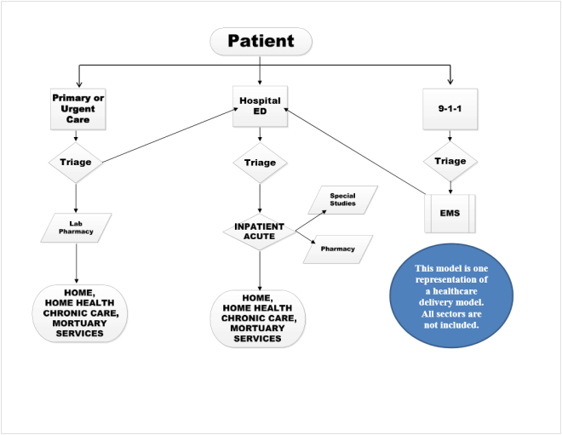
Community MOC Diagram Example 1

Community MOC Diagram Example 2
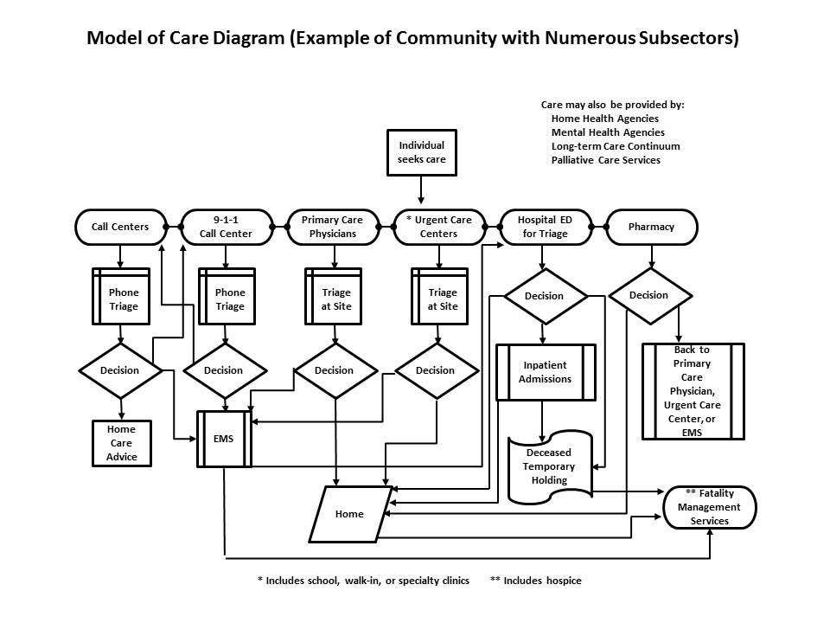

MOC Narrative
A MOC narrative is a written description of the interconnected sequence of events in a community's healthcare delivery system. A MOC narrative includes the following components:
- Community Background/Demographics
See Worksheet 3.1 – Community Demographic Assessment Worksheet
- Core Partners and Their Capacities
See Worksheet 3.3 – Partner Identification Checklist
- Noncore Partners and Their Capacities
See Worksheet 3.3 – Partner Identification Checklist
- Patient Flow
See the example MOC diagrams on the previous pages

A sample MOC narrative is provided in Appendix C. Use this sample as a guide to complete a narrative for your community. Upon completion of your MOC narrative, you and your planning team should review it and your MOC diagram to make sure you have accurately described the delivery of healthcare in your community on a day-to-day basis. You should make revisions to either component as needed before proceeding to the next step.

Evaluate Your MOC Diagram and Narrative with Your Partners
Once you and your planning team have completed your MOC diagram and narrative, you should share it with those core and noncore partners described in the diagram or the narrative. Preferably, you should meet with these partners in person (i.e., in a workshop or discussion-based exercise) to "walk through" the diagram and narrative in a step-by-step process to confirm that the
- MOC diagram includes all points of healthcare delivery (i.e., all relevant core and noncore partners) within your community
- MOC narrative also includes these points of healthcare delivery and accurately reflects the roles, responsibilities, capabilities, and special considerations for sectors and subsectors identified in the narrative

Any omissions you discover in your MOC diagram or narrative should be corrected. Your revised MOC diagram or narrative should be sent to your partners for review and approval. (Using e-mail for this review is sufficient.)

Another important aspect of the evaluation of your MOC diagram and narrative is to identify points in your community's healthcare delivery system where the delivery of service is falling short or may fall short. Examples of shortfalls are
- 9-1-1 has higher call capacity than EMS has assets to dispatch to handle these callers.
- The community hospital is open 24/7 but the community pharmacy is open only from 9:00 am to 5:00 pm.
- All hospitals and urgent care centers in the community rely on the same vendor for key medical supplies.
- Public health and emergency management use information sharing systems that are not interoperable (i.e., cannot communicate with each other).

Use Worksheet 3.5 – Service Delivery Shortfalls/Issues below to capture this information. At this point, you are only identifying these shortfalls. Determining how to address them will be covered in the next step when you meet with your community coalition.

Worksheet 3.5 – Service Delivery Shortfalls/Issues
Instructions: In the space provided, describe the points in your community's healthcare delivery system where the delivery of service is falling short or may fall short. Next to each service delivery shortfall, list the partners that are involved in the delivery of that service.
Shortfall/Issue Description | Partners Involved
To be filled in | To be filled in
To be filled in | To be filled in
To be filled in | To be filled in
To be filled in | To be filled in
To be filled in | To be filled in

Validate Your MOC Diagram and Narrative with Your Coalition
The last step in this chapter is for you and your planning team to share the work you have completed up to this point with your community coalition for validation. In this context, validation means making sure the coalition agrees with your MOC diagram and narrative and other findings you present to them, such as the service delivery shortfalls you identified above or the demographic issues you identified in Worksheet 3.2.

If your coalition suggests changes to your MOC diagram or narrative, you and your planning team should make these changes before proceeding to the next chapter. Additionally, any changes made to the diagram or narrative should be shared with your core and noncore partners.

With regard to service shortfalls or other issues you may have identified, you should ask your coalition for input on what priority to give these shortfalls/issues and how to resolve them. Use Worksheet 3.6 – Shortfall/Issue Resolution below to document your coalition's input.

Worksheet 3.6 – Shortfall/Issue Resolution
Shortfall/Issue Description | Priority for Resolution | Responsible Partners | Due Date | Complete?
To be filled in | To be filled in | To be filled in | To be filled in
To be filled in | To be filled in | To be filled in | To be filled in
To be filled in | To be filled in | To be filled in | To be filled in
To be filled in | To be filled in | To be filled in | To be filled in
To be filled in | To be filled in | To be filled in | To be filled in
To be filled in | To be filled in | To be filled in | To be filled in
To be filled in | To be filled in | To be filled in | To be filled in
Instructions: List each shortfall/issue identified in Worksheet 3.5. For each shortfall/issue, identify the priority for resolution (high, medium, low), the partners responsible for addressing the shortfall/issue, and the date the shortfall/issue should be resolved. As these shortfalls/issues are resolved, place a check mark in the Complete? column.

After you have determined your plan for resolving service shortfalls or other issues you have identified, you have completed this chapter in the Framework. Proceed to the self-evaluation checklist on the next page to confirm that all tasks in this chapter have been completed.

Self-Evaluation Checklist
Chapter 3 – Documenting Day-to-Day Healthcare Delivery Self-Evaluation Checklist
Instructions: Use this checklist to make sure you have completed all the tasks for documenting your community's day-to-day healthcare delivery.
Community Demographics and Partner Assessment
Task | Complete?
A community demographics assessment has been conducted. (Worksheet 3.1)
Demographic issues have been identified and documented. (Worksheet 3.2)
The community's core and noncore partners have been identified. (Worksheet 3.3)
An assessment of core and noncore partners has been completed. (Worksheet 3.4)

MOC Diagram and MOC Narrative
Task | Complete?
The community's most common points of entry (e.g., primary care, hospital, 9-1-1) into the healthcare system have been identified and placed on the diagram.
The normal path a patient would follow from each of these points of entry has been identified and indicated on the diagram.
Exit paths have been identified and placed on the diagram.
A written description of the community background and demographics has been completed.
A written description of the community's core partners and their capacities has been completed.
A written description of the community's noncore partners and their capacities has been completed.
A written description of patient flow through the community's healthcare system has been completed.

MOC Diagram and Narrative Evaluation
Task | Complete?
The MOC diagram has been evaluated with core and noncore partners.
The MOC narrative has been evaluated with core and noncore partners.
Changes to the MOC diagram or narrative have been made, as needed.
Service delivery shortfalls have been identified. (Worksheet 3.5)
The MOC diagram has been validated by the community coalition.
The MOC narrative has been validated by the community coalition.
Changes to the MOC diagram or narrative have been made, as needed.
Service shortfalls or demographic issues have been prioritized for resolution and assigned to relevant partners to resolve. (Worksheet 3.6)

Conclusion
The purpose of this chapter was for you and your planning team to fully understand how your community delivers healthcare on a day-to-day basis. Just as developing a planning team and a coalition is the backbone of community preparedness planning, gaining an understanding of day-to-day healthcare delivery is the backbone of medical surge planning because surge planning requires modifications to your day-to-day model of care. Therefore, if you think your planning team and community coalition have completed their work tasks as outlined in this chapter, please go to the next chapter to begin working on your community's plan for moderate surge.

References and Resources
Community Assessment Tool
http://www.cdc.gov/phpr/healthcare/communities.htm
This planning tool developed by CDC is intended for use by a community to assess its readiness for a disaster from a total healthcare system perspective. The CAT helps reveal each core agency partners' capabilities and resources, highlights cases of the same vendors being used for resource supplies by the partners, and address gaps in the community's capabilities or potential shortages in resources.

Homeland Security Exercise and Evaluation Program (HSEEP)
https://www.fema.gov/media-library/assets/documents/32326
Developed by the U.S. Department of Homeland Security, HSEEP provides a set of guiding principles for exercise programs, as well as a common approach to exercise program management, design and development, conduct, evaluation, and improvement planning. Partners can use the process outlined in this program to develop a discussion-based exercise to evaluate the accuracy of the community MOC diagram and narrative.

Pandemic Influenza Electronic Exercise Tool
(To be available soon)
Developed by CDC-HPA, this tool provides a means for communities to exercise and improve pandemic influenza plans without the need for in-person exercises.

Medical surge is defined as the ability to provide adequate medical evaluation and care during events that exceed the limits of the normal medical infrastructure of an affected community (through numbers or types of patients). It encompasses the ability of healthcare organizations to survive a hazard impact and maintain or rapidly recover operations that were compromised (a concept known as medical system resiliency).
IOM uses the term, conventional capacity, to define the day-to-day provision of healthcare. In defining conventional capacity, IOM states that the spaces, staff, and supplies used are consistent with daily practices within the institution. These spaces and practices are used during a major mass casualty incident that triggers activation of the facility emergency operations plan. (See http://www.ncbi.nlm.nih.gov/books/NBK32751/)
Some of this information may have been collected already as part of your Community Health Needs Assessment performed under the umbrella of the Affordable Care Act of 2010.
The authors of this document consider the term partner(s) to include both core and noncore sectors and their subsectors.
The MOC diagram and narrative may be developed in an order suitable to your planning team (i.e., either the MOC diagram first followed by the narrative or narrative first followed by the diagram).
Points of entry refer to the places where a patient seeks care or is taken for care. Common points of entry are primary care providers, urgent care centers, hospital EDs, and phone calls to 9-1-1.

