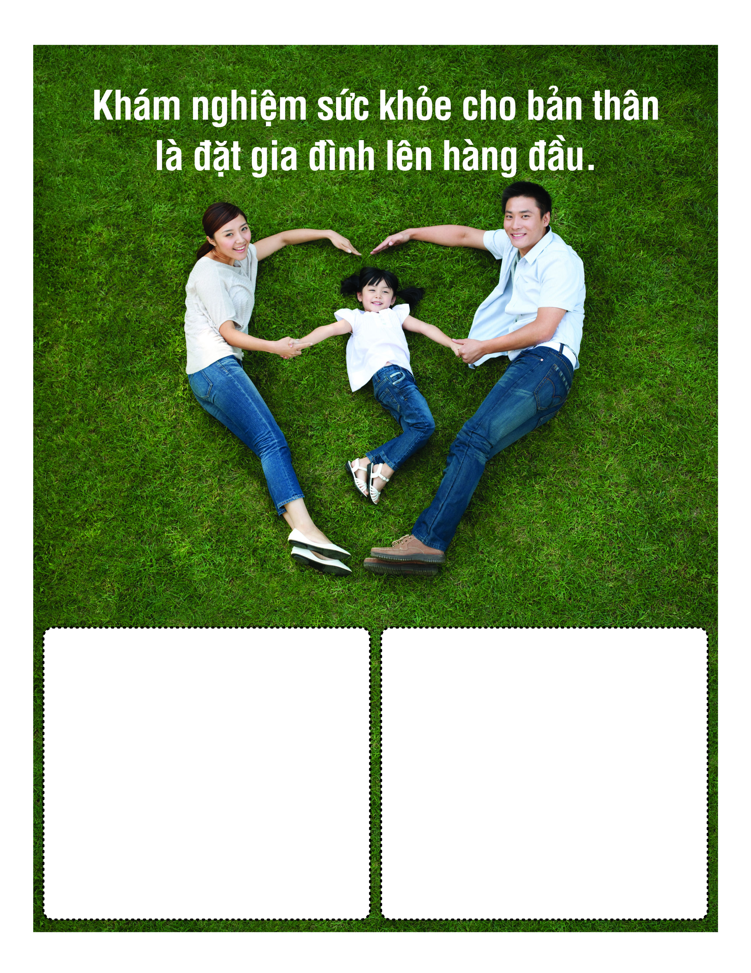

Thoâng tin veà khaùm nghieäm söùc khoûe.

Sunday, May OO, 2014 | 10AM-3PM

Sponsoring Organization Name

100 Main Street, | City, State

Call (123) 456-7899 for

more information